Adsorption Studies on citrofortunella microcarpa (fruit peel of calamansi): Recovery of Cadmium from Synthetic Mining Wastewater
R.L.A. Caram*, M.I.S. Dela Cruz, K.M.M. Lasala, J. Colades
Environmental Engineering Program, University of the Philippines Diliman
* rlacaram@gmail.com
Keywords: adsorption; biosorption; cadmium; calamansi
Introduction
Cadmium is a metal by-product of mining Zinc and Copper, two of the major metals produced in the Philippines [4] [5]. Cadmium is a carcinogenic, toxic and a teratogenic, which may be fatal to kidneys, skeletal and respiratory systems. As a pollutant, it can: travel long distances through air, be dissolved in soft or acidic water, and move through soil layers and enter the food chain through the uptake of plants.
One of the major fruit crops in the Philippines is the Calamansi which has gained popularity in cooking, cosmetic and detergent industries [16]. As it becomes more popular, the projected increase in demand for its juice, may bring about another potential environmental problem as there is no known use for the calamansi peel aside from making compost. In response to this, this study aimed to determine the feasibility of using citrofortunella microcarpa (fruit peel of calamansi) as a possible biosorbent for cadmium in cadmium-contaminated mining wastewater. The study used synthetic cadmium solution in the evaluation of the adsorption capacity of the peel with respect to contact time, pH of the solution and adsorbent concentration. The desorption capacity of the adsorbent and regeneration studies were conducted as well.
Material and Methods
This methodology is patterned from the study conducted by Ajmal et al on the biosorption of nickel using orange peel. [12] Calamansi peels were cut into 150 mm parts, washed and dried in an air oven at 100°C for 24 hours. A stock solution of cadmium had a concentration of 474 mg/L.
Adsorption studies were divided into three categories: parametric, optimization and confirmation tests. All cadmium concentrations of the resulting solutions, including the control for each batch, were analysed using the Atomic Absorption Spectrophotometer (AAS) Shimadzu model AA6300. The adsorption of cadmium on the calamansi peel is assumed to be equal to the cadmium removed from synthetic wastewater. All adsorption studies made use of 50-mL stock solution for each test run. The optimization test was designed via Response Surface Methodology (Box-Behnken Configuration) of Stat-ease Design Expert v.10, using the resultant values from the parametric studies. The kinetic adsorption study was performed at the determined optimum (pH, adsorbent concentration, contact time) from the optimization test were performed with 30 minutes interval between runs.
The desorption of Cadmium utilized adsorbents used in the confirmation test which were filtered out and treated with 0.05M HCl solution, with varying contact times: 0.5 h, 1.5h and 2.0 h. Regeneration studies were also done. Adsorption was done at pH 4 using 2.5g of adsorbent for an hour. Adsorbents were then filtered out and treated with 50-mL of 0.05M HCl solution for 30 minutes. After desorption, the adsorbents were filtered and the process was repeated. Scanning Electron Microscope (SEM) test was done determine the impact of surface morphology of calamansi peel on adsorption.
Results and Conclusions
3.1 Parametric Studies
The parametric study on the effect of contact time shows that increasing the contact time increases removal efficiency, hence, the range for the contact time for the optimization run was set to 3 hours to 6 hours. The parametric study on the effect of pH on adsorption shows that adsorption is low at lower pH values because the H⁺ ions, which are more mobile than Cd²⁺ ions compete for the active sites of the calamansi peel. Adsorption increases with pH until pH 5 before it decreases, hence the pH range for the optimization process was set at pH 4 to pH 6. The parametric study on the effect of adsorbent concentration shows that adsorption increases with the amount of adsorbent which could be due to the increase in the number of active sites at which cadmium ions adsorb. Hence for the optimization run, the range for concentration was set to 2.5g/50mL to 7.5g/50mL.
3.2 Optimization Study
Response surfaces of this study are presented in Figures 1 a,b, and c. The maximum cadmium removal (62.2%) is achieved at pH 4, 6 hours contact time, and adsorbent concentration of 7.5g/50mL. Figure 1a shows the response surface at a constant contact time of 6 hours, 1b at constant adsorbent concentration of 7.5g/50mL, and 1c at constant pH 4. Figures 1a and 1b have narrow ranges for removal rates, and values are generally high. Based on the pH side, the slope is relatively small which could mean that it does not greatly affect the removal rate of cadmium from the solution. Meanwhile, in figure 1c, there is a wider range of removal rate (30%-65%), and is increasing as both contact time and adsorbent concentration increases. Considering practical application of the results, the size of adsorbent needs to be decreased to increase its surface area.
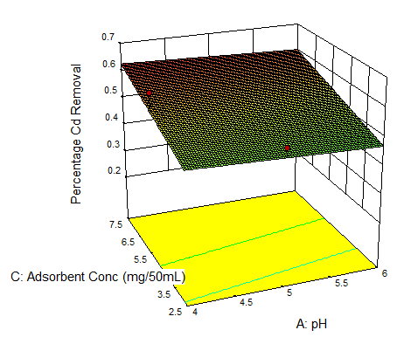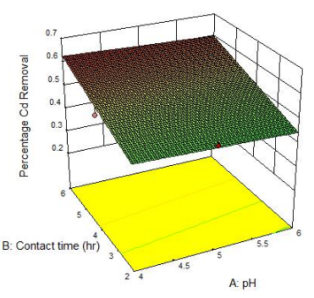
a.
b.
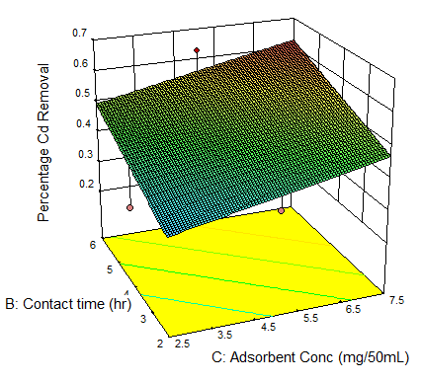
c.
Figure 1. (a) Response surface at contact time of 6 hours (b) Response surface at adsorbent concentration equals 7.5g/50mL (c) Response surface at pH 4
3.3 Adsorption Kinetics
As shown in Figure 2 the kinetic curve increases sharply until four-hour contact; after which, the increase in adsorption became minimal. This shows that beyond 4 hours, most active sites may have been used up and the calamansi peel may have been fully saturated.
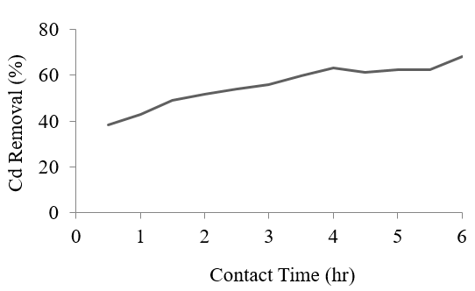
Figure 2. Adsorption kinetics of cadmium ions

3.4 Confirmation and Desorption Studies
The optimum point is repeatable and the percent of adsorption from the confirmation study are close to the percent of adsorption from the optimization study (62%). Different contact times have been used for desorption but the desorption rates obtained were close to each other. The obtained rate of desorption is inferior to other studies having a range of 94-97% [11].

3.5 Regeneration Study
As shown in Table 1 the resulting percent of adsorption is less than the results obtained in the optimization and confirmation studies since each cycle was only done for one hour, while the results for desorption are higher than the desorption study. For the 2nd cycle, there was a decrease in adsorption and increase in desorption. The results are inferior to other studies [12], although some studies state that biosorbents generally have a low regeneration rate [14].
Table 1. Regeneration Study Results
Cycle | Adsorption (%) | Desorption (%)
1 | 49 | 52
2 | 41 | 83

References
[1] Philippine Statistics Authority, “National Accounts Latest Estimates,” 2016.
[2] Philippine Statistics Authority, “2013 Annual Survey of Philippine Business and Industry - Mining and Quarrying for All Establishments: Final Results,” 2016. [Online]. Available: https://psa.gov.ph/content/2013-annual-survey-philippine-business-and-industry-mining-and-quarrying-all-establishments. [Accessed: 02-Sep-2016].
[3] World Health Organization, “Preventing Disease Through Healthy Environments.” [Online]. Available: http://www.who.int/ipcs/assessment/public_health/chemicals_phc/en/. [Accessed: 01-Sep-2016].
[4] United Nations Environment Program, “Final review of scientific information on cadmium,” 2010.
[5] Philippine Statistics Authority, “Mines and Minerals Philippine Yearbook 2013,” 2013.
[6] Royal Society of Chemistry, “Cadmium.” [Online]. Available: from: http://www.rsc.org/periodic-table/element/48/cadmium. [Accessed: 02-Sep-2016].
[7] World Health Organization, “Cadmium,” International Program on Chemical Safety. .
[8] M. Nordberg, “CADMIUM | Toxicology,” in Encyclopedia of Food Sciences and Nutrition, 2003, pp. 739–745.
[9] Agency for Toxic Substances & Disease Registry, “Cadmium Toxicity Where is Cadmium Found?” [Online]. Available: http://www.atsdr.cdc.gov/csem/csem.asp?csem=6&po=5. [Accessed: 02-Sep-2016].
[10] D. Purkayastha, U. Mishra, and S. Biswas, “A comprehensive review on Cd(II) removal from aqueous solution,” J. Water Process Eng., vol. 2, pp. 105–128, 2014.
[11] N. Feng, X. Guo, S. Liang, Y. Zhu, and J. Liu, “Biosorption of heavy metals from aqueous solutions by chemically modified orange peel,” J. Hazard. Mater., vol. 185, no. 1, pp. 49–54, 2011.
[12] M. Ajmal, R. A. K. Rao, R. Ahmad, and J. Ahmad, “Adsorption studies on Citrus reticulata (fruit peel of orange): Removal and recovery of Ni(II) from electroplating wastewater,” J. Hazard. Mater., vol. 79, no. 1–2, pp. 117–131, 2000.
[13] M. Torab-Mostaedi, M. Asadollahzadeh, A. Hemmati, and A. Khosravi, “Equilibrium, kinetic, and thermodynamic studies for biosorption of cadmium and nickel on grapefruit peel,” J. Taiwan Inst. Chem. Eng., vol. 44, no. 2, pp. 295–302, 2013.
[14] H. P. Chao, C. C. Chang, and A. Nieva, “Biosorption of heavy metals on Citrus maxima peel, passion fruit shell, and sugarcane bagasse in a fixed-bed column,” J. Ind. Eng. Chem., vol. 20, no. 5, pp. 3408–3414, 2014.
[15] H. N. Bhatti, Q. Zaman, A. Kausar, S. Noreen, and M. Iqbal, “Efficient remediation of Zr(IV) using citrus peel waste biomass: Kinetic, equilibrium and thermodynamic studies,” Ecol. Eng., vol. 95, pp. 216–228, 2016.
[16] Department of Agriculture, “Citrus Fruits.” [Online]. Available: http://www.da.gov.ph/images/PDFFiles/FarmingTips/HighValueCrops/citrus.pdf.
[17] Philippine Statistics Authority, “Major Fruit Crops Quarterly Bulletin,” 2016. [Online]. Available: https://psa.gov.ph/fruits-crops-bulletin/calamansi. [Accessed: 17-Sep-2016].

